

# AUTOMATION TESTING ON

# HCL - LMS



**Members Worked on This Project**

1. Tummidi Raghavendra Rao
2. Emmalla Pradeepthi
3. Manjula M
4. Aditya Kuna
5. Nisha Gautham
6. Shivani Yadav

# **Table Of Content**

1.1 Project Overview ----------------------------------------------------4

1.2 Scope -------------------------------------------------------------------5

1.3 Features ---------------------------------------------------------------6

1.4 Flow Control ----------------------------------------------------------7

1.5 User Characteristics------------------------------------------------10

1.6 Advantages-----------------------------------------------------------11

1.7 Use Cases detailed--------------------------------------------------12

1.8 Sequence Diagram--------------------------------------------------13

1.9 Database Entity Relationship Diagram-------------------------14

1.10 Specific Requirements---------------------------------------------15

1.11 Technical Detailed Description----------------------------------16

1.12 Software System Attributes --------------------------------------20

# **Project Overview**

A Learning Management System (LMS) is a software application or web-based technology used to plan, implement and assess a specific learning process. It is used for eLearning practices and, in its most common form, consists of two elements: a server that performs the base functionality and a user interface that is operated by Trainer, Scholar and Administrators.

In this project we perform Automation testing on Learning Management System (LMS) using Selenium Web Driver by creating Maven project in the Eclipse and we use some Maven repositories like TestNG, Extent Report and Apache POI.

In the LMS, we have so many modules like scorecard, Daily Quiz, Courses, Feedback, Assessment etc., On the whole Learning Management System, we took Three Modules for Automation Project.

1. Viewing Scorecard
2. Accessing Course
3. Checking Daily Quiz Score

## **Viewing Scorecard**

Scorecard is one of the Module in Learning Management System. Here Scholar will be able to check the Attendance, Performance of the Scholar like Scores of MCQ Assessments, Lab Assessments, Communication Assessments and IKM Assessments.

## **1.1.2 Accessing Course**

It is the most important module in Learning Management System. Here Scholar will be able to Access the course according to the domain allocated by the Administrator.

## **1.1.3 Checking Daily Quiz Score**

Daily quiz is one of the module in Learning Management System. Here scholar will be able to attend the daily quiz after completing the quiz, he can view the score.

# **Scope**

The proliferation of connected devices, coupled with a shift towards Scholar-oriented ways of teaching, is changing the very core of learning management systems. Consequently, the internet is fast becoming the preferred adaptive learning platform for learning management as individuals increasingly access online resources via smartphones and tablets.

With this in mind, HCL has architected an adaptive Learning Management System (LMS) that uses digital media to make education more interactive and engaging. We help bring together Scholar and Trainer.

In this project, we check the specific requirements of Learning Management System (LMS) like checking the Scorecard of Scholar, Viewing the Courses, Attempting the Daily quiz, Login and Logout functionalities.

HCL’s adaptive learning platform is supported by a number of essential features:

* Digital add-on’s, such as audio and video’s illustrations, online assignment submission and collaborative teaching.
* Incorporation of both Scholar as well as Trainer perspective for a holistic approach to learning.
* Real-time access to the learner’s growth trajectory for all participants.
* Personalized recommendations for improvement via adaptive learning software.

# **1.3 Features:**

The following features of this project have made it more users friendly, efficient and secured.

1. It enables the scholars to provide individual user account to each student.
2. All the user accounts (scholars) are password protected. So, the database can be termed as secured.
3. In Learning Management System, only administrative section is allowed to create the account, but scholars can register with application.
4. By using the credentials created by administrator, scholar login to Learning Management System and can access the courses allocated for them.
5. By using TestNG we are getting reports for each and every test.
6. By using Data-driven frame work (Apache POI) we are taking the data from the Excel sheet.
7. By using Extent Reports, we are getting detailed report for each and every test.

# **1.4 Flow Control:**

## **1.4.1 Flow diagram for score card:**

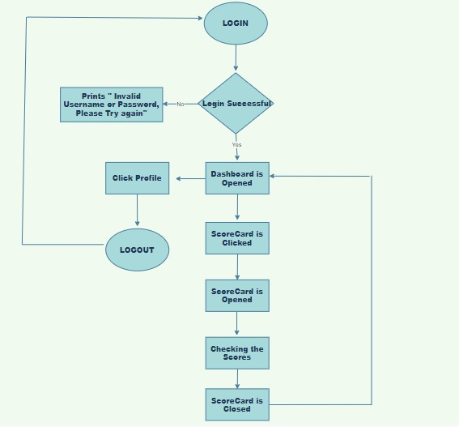

## **1.4.2 Flow diagram for Course:**

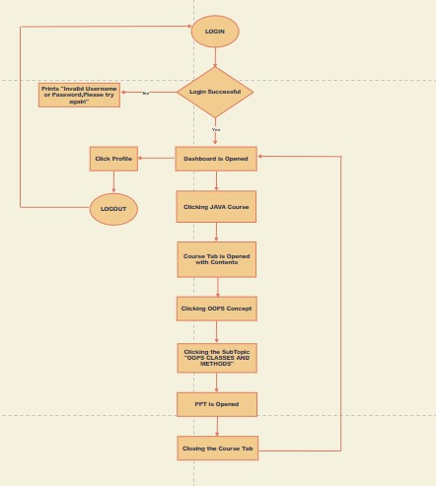

## **1.4.3 Flow diagram for Daily Quiz:**

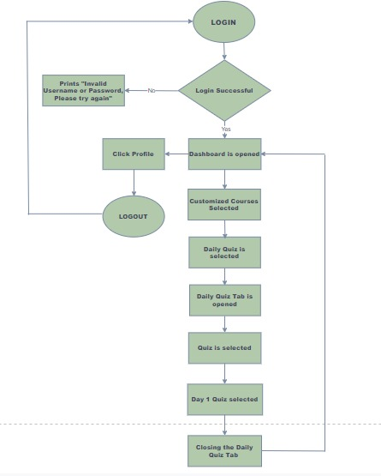

# **1.5 User Characteristics:**

An Learning Management System (LMS) is a software which assists the users with e-learning programs by hosting, managing, organising and evaluating the web-based courses for the learners. Like the spine of e-learning system, LMS provides a support framework to the learning process.

While the characteristics of a learning management system depend to a great extent on the requirement of an organization. However, there are certain essential characteristics that every LMS must possess. Let’s have a look at the top 5 characteristics of a good LMS.

### **1.   User-friendly Interface**

Maximum benefits of an LMS can only be obtained if the users completely understand the system. Hence, it must be easy to use. An LMS with user-friendly interface enables the users to easily understand its features and utilize them optimally. This is specifically useful for beginners as it reduces the on-boarding time and users can learn to use the system faster.

### **2.   Customization Flexibility**

There is no one-size-fits-all formula when it comes to learning management system. As stated above, requirements of every business vary; thus, they require different features that facilitate their operations. A good LMS must offer customisation options to the users so that it can be tweaked for their convenience without relying on external help. It saves time and makes the system more effective for the organization.

### **3.   Regular Updates**

As the learning industry is changing, it is now important for an organization’s LMS to evolve with it. It is essential that the LMS provides regular updates, new functionality and modification of existing features accommodating the latest changes in the learning industry.

### **4.   Integrated Learning**

Lastly, the LMS must support integrated learning. In the modern world, organizations use various training methodology to train their employees like classroom training, blended learning and mobile learning. The learning management system should be able to support a gamut of training programs so that users can access them as per their need. It should also be integration friendly with existing business applications to be able to provide a centralised and automated learning experience.

# **1.6 Advantages:**

* + [The ability to organise learning and course content](https://blog.mmgrowth.com/benefits-learning-management-system-lms#one)
  + [Learning tracking](https://blog.mmgrowth.com/benefits-learning-management-system-lms#four)
  + [Compliance, governance and certification](https://blog.mmgrowth.com/benefits-learning-management-system-lms#five)
  + [Life-long blended learning](https://blog.mmgrowth.com/benefits-learning-management-system-lms#six)
  + [Integrating learning with project launch and delivery](https://blog.mmgrowth.com/benefits-learning-management-system-lms#seven)
  + [Cost-effective corporate training](https://blog.mmgrowth.com/benefits-learning-management-system-lms#nine)
  + [Updating content in real time](https://blog.mmgrowth.com/benefits-learning-management-system-lms#ten)
  + [Flexible access for learners](https://blog.mmgrowth.com/benefits-learning-management-system-lms#eleven)
  + [Social media reinforced learning](https://blog.mmgrowth.com/benefits-learning-management-system-lms#twelve)
  + [Web based learning tools](https://blog.mmgrowth.com/benefits-learning-management-system-lms#thirteen)
  + [Software as a Service (SaaS)](https://blog.mmgrowth.com/benefits-learning-management-system-lms#thirteen)

# **1.7 Use Cases detailed:**

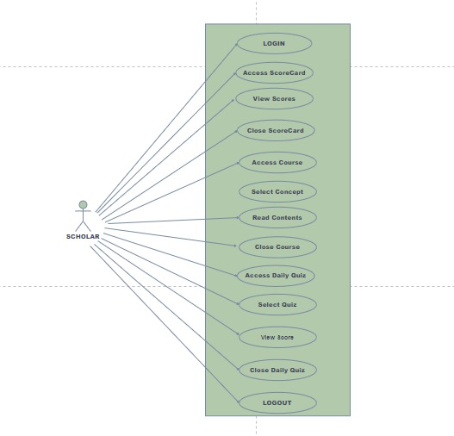

# **1.8 Sequence Diagram:**

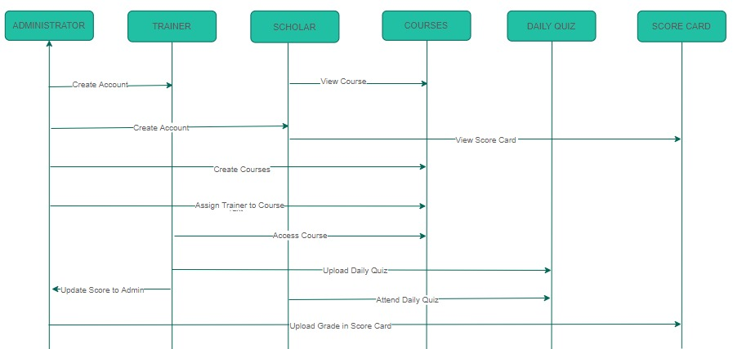

# **1.9 Database Entity Relationship Diagram:**

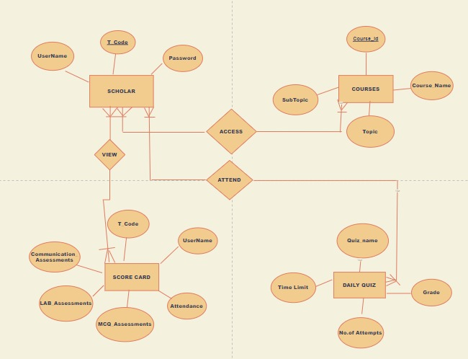

# **1.10 Specific Requirements:**

## **1.10.1 Viewing Score card:**

Once the scholars logged in to the lms portal, the scholars click on the scorecard and it allows the scholars to view their scores and after viewing the scores the scholar close the scorecard tab and returns to dashboard.

## **1.10.2 Accessing Scores:**

Once the scholar logged into the lms portal, the Scholar check the courses and he/she click on the course assigned for him/her and he/she get access for that course, after completing the course the scholar will logout and return to home page.

## **1.10.3 Checking the Daily Quiz Scores:**

Once the scholar logged into the lms portal, the scholar checks the daily quiz module and Here scholar will be able to attend the daily quiz after completing the quiz, he can view the score and the scholar will logout and return to homepage.

# **1.11 Technical Detailed Description:**

**GitHub Link :** [**https://github.com/Raghava1317/Automation**](https://github.com/Raghava1317/Automation)

To Automate LMS we choose Maven project instead of Java project from Eclipse. The reason why we choose Maven project is it has so many advantages like

* A huge, continuously growing repository of user libraries
* The ability to set up projects easily, using best practices
* Dependency management, featuring automatic updating
* Backwards compatible with previous versions
* Strong error and integrity reporting
* Automatic parent versioning
* Ensures consistent usage across all projects
* It’s extensible, and you can easily write plug-ins using scripting languages or Java.

**Maven** is so useful thanks to the Project Object Model (POM), which is an XML file that has all the information regarding project and configuration details. The POM has the description of the project, details regarding the versioning, and configuration management of the project.

The XML file is located in the project home directory. When you execute a task, Maven searches for the POM in the current directory. We add some dependencies from Maven repository like TestNG, Extent report, Selenium Web Driver, Apache POI.

**TestNG** is a testing framework that is capable of making Selenium tests easier to understand and of generating reports that are easy to understand. The main advantages of TestNG over JUnit are the following.

* + Annotations are easier to use and understand.
  + Test cases can be grouped more easily.
  + TestNG allows us to create parallel tests.

The Console window in Eclipse generates a text-based result while the TestNG window is more useful because it gives us a graphical output of the test result plus other meaningful details such as:

* + Runtimes of each method.
  + The chronological order by which methods were executed

TestNG is capable of generating HTML-based reports. Annotations can use parameters just like the usual Java TestNG methods. TestNG Data provider is a way to pass parameters into the test function which passes different values in test cases in a single execution.

**Extent Reports** is an open-source reporting library useful for test automation. It can be easily integrated with major testing frameworks like JUnit, TestNG, etc. These reports are HTML documents that depict results as pie charts. They also allow the generation of custom logs, snapshots, and other customized details.

Once an automated test script runs successfully, testers need to generate a test execution report. While TestNG does provide a default report, they do not provide the details.

**Data Driven** **Frame work:** In Generally, when we test an application manually, we run the same scenario for multiple test data. Additionally, we keep the same test data in some files like Excel Files, Text Files, CSV Files, or any database. The same is true for automation also, where we would like to run the same test scenario for multiple test data.

**Automation Frame Work:**

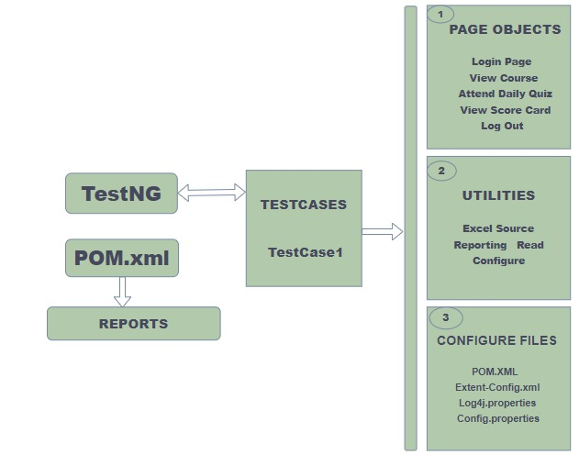

**1.11.1 TestNG Report**

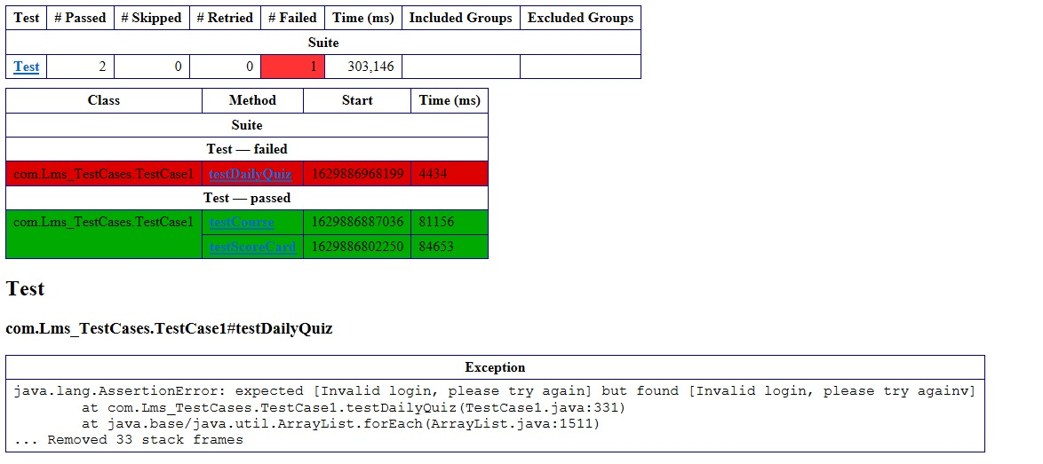

**1.11.2 Extent report for Viewing scorecard test case:**

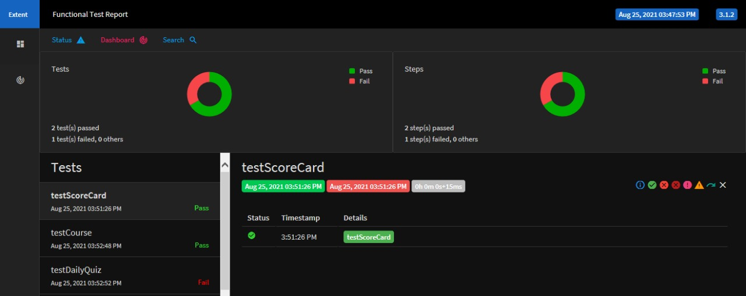**1.11.3 Extent report for Accessing course testcase:**

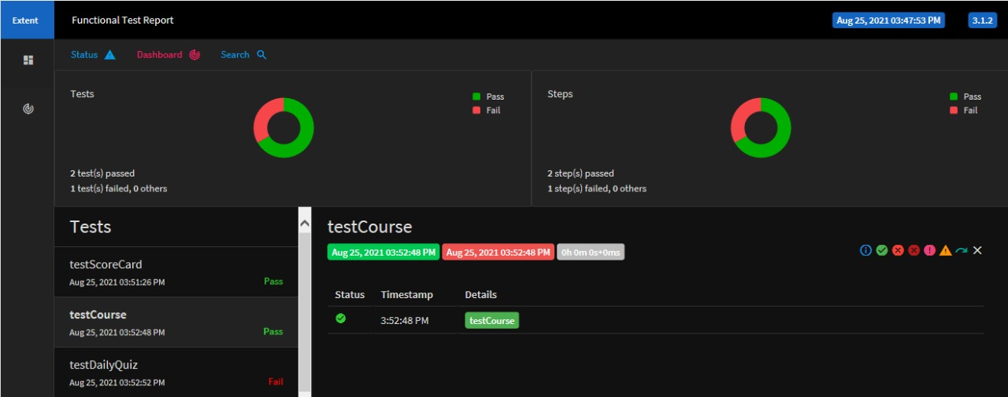

## **1.11.4 Extent report for checking Daily quiz testcase:**

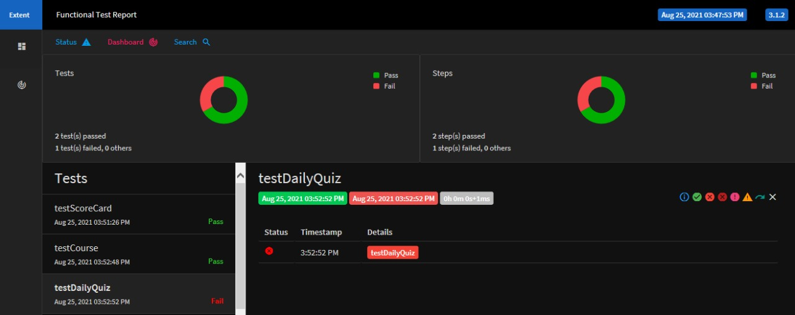

**1.11.5 Log File**

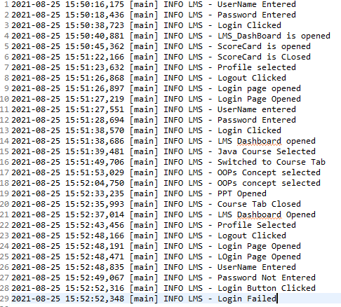

# **1.12 Software System Attributes:**

# **1. Security:**

**Firewall Protection:** The Learning Management system shall run inside a firewall.

**Support different roles:** The system shall support different roles for users, such as Trainer, Scholar, and administrative staff, the user logged in with given role should only be allowed access consistent with that role. For example, a scholar shall only be allowed to see he/she scorecard and not to modify it.

# **2. Reliability:**

The system shall not be down more than 2 times in year.

# **3. Scalability:**

**Scaling system to large number of users**: large courses will have hundreds of scholars.

The system shall be able to handle the load for such courses, especially during Daily quiz when many scholars can be expected to access the Learning Management system.